**========Project 6=======**

Name- **Installing and Configuring Apache tomcat server on Linux**

**Installing Java:** yum install java-1.8* - This command is used to install the java18

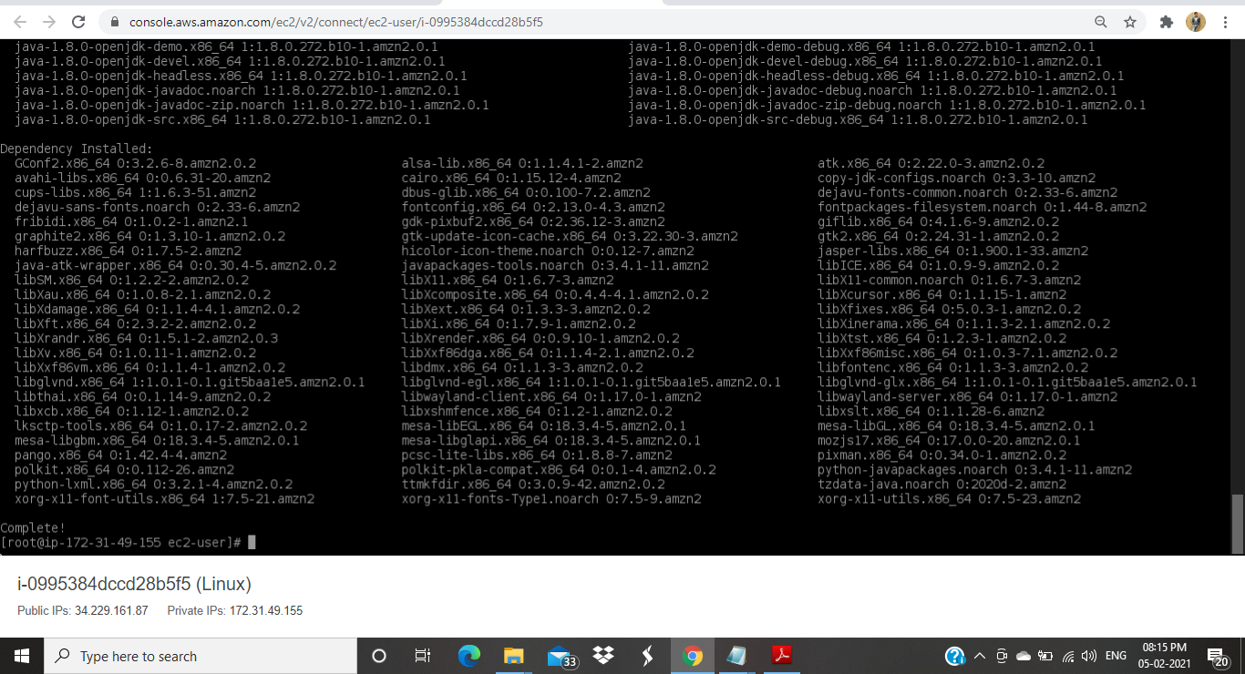

**Fig 1. Java 1.8 Installed**

**Installing tomcat –**

**cd /opt**

**wget** [**https://mirrors.estointernet.in/apache/tomcat/tomcat-8/v8.5.63/bin/apache-tomcat-8.5.63.tar.gz**](https://mirrors.estointernet.in/apache/tomcat/tomcat-8/v8.5.63/bin/apache-tomcat-8.5.63.tar.gz)

**Above command is used to download the Apache tomcat 8.5.63**

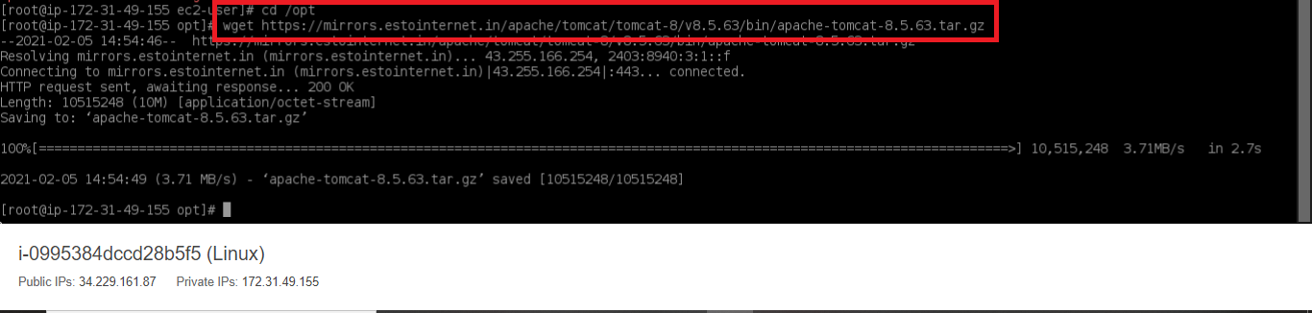

**To extract the downloaded file - tar -zvxf apache-tomcat-8.5.61.tar.gz**

**To list the files - ls**

**To list the process named tomcat - ps -ef | grep tomcat**

**For long listing with permissions - ls -ltr**

**Modify permissions for startup.sh and shutdown.sh -**

**chmod +x startup.sh**

**chmod +x shutdown.sh**

**To print the path – echo $PATH**

**To find the location of file - find / -name startup.sh**

**Used to create softlinks to start and stop the tomcats -**

**ln -s path /usr/bin/tomcatup**

**ln -s path /usr/bin/tomcatdown**

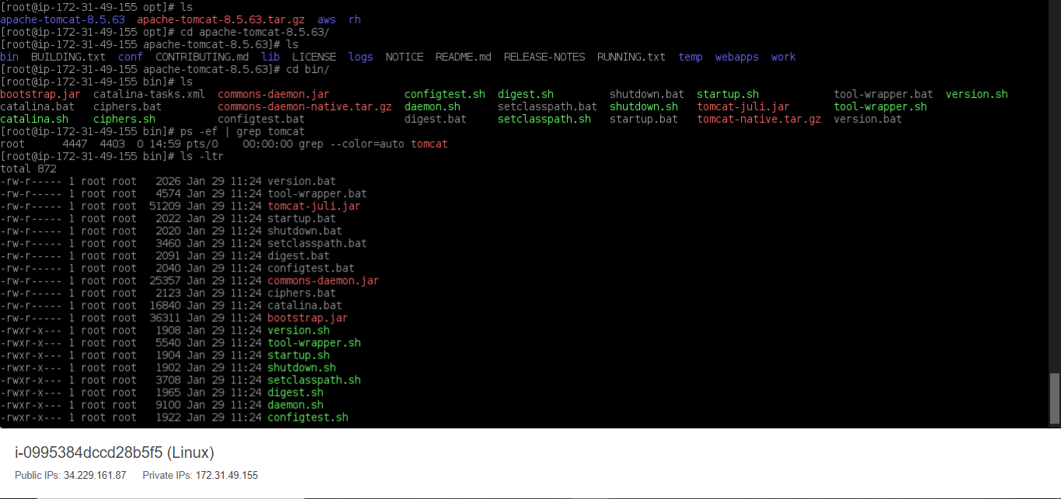

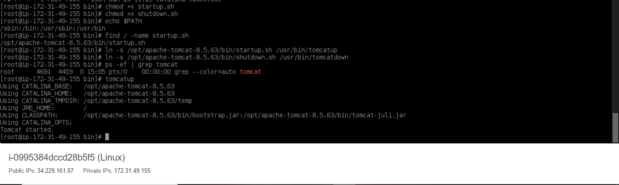

**To launch the tomcat with public IP and default port-8080 -**

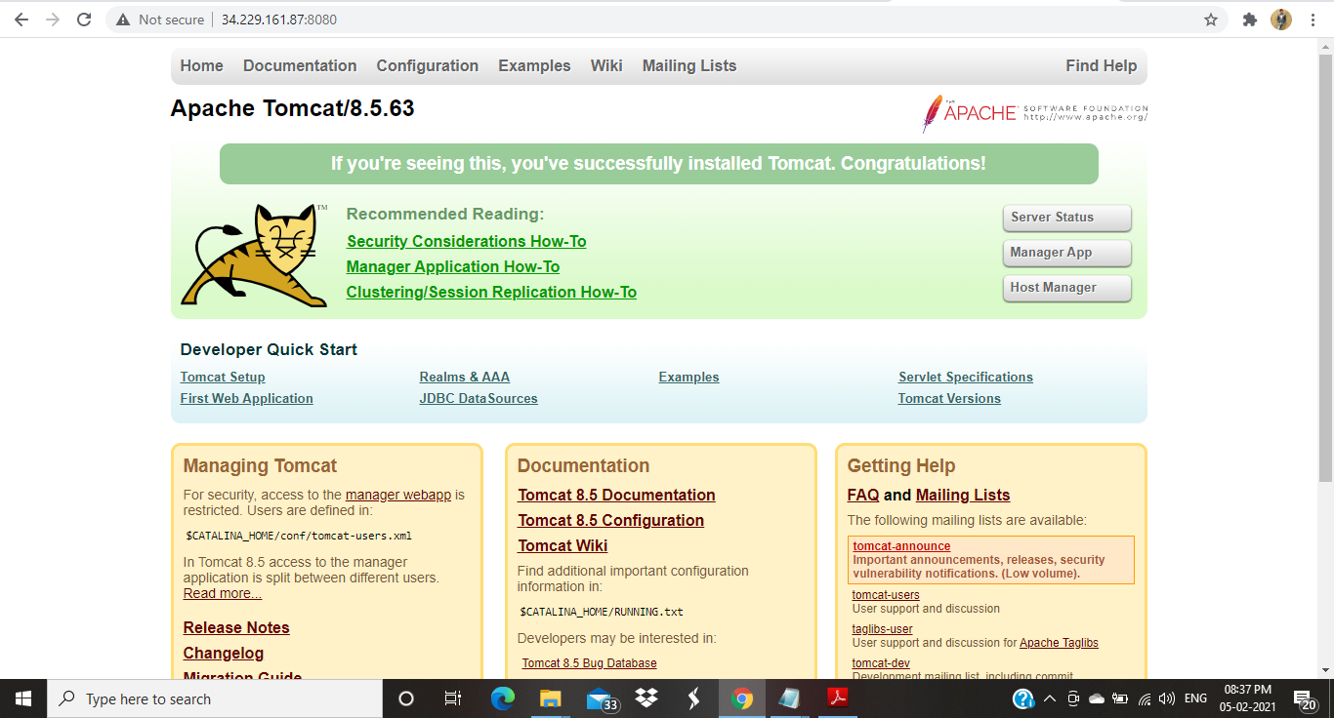

**Changing the connector port to 8090 in server.xml file – vi server.xml**

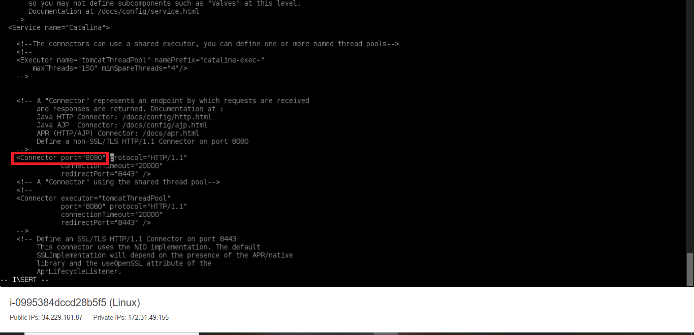

**Launched using port 8090 -**

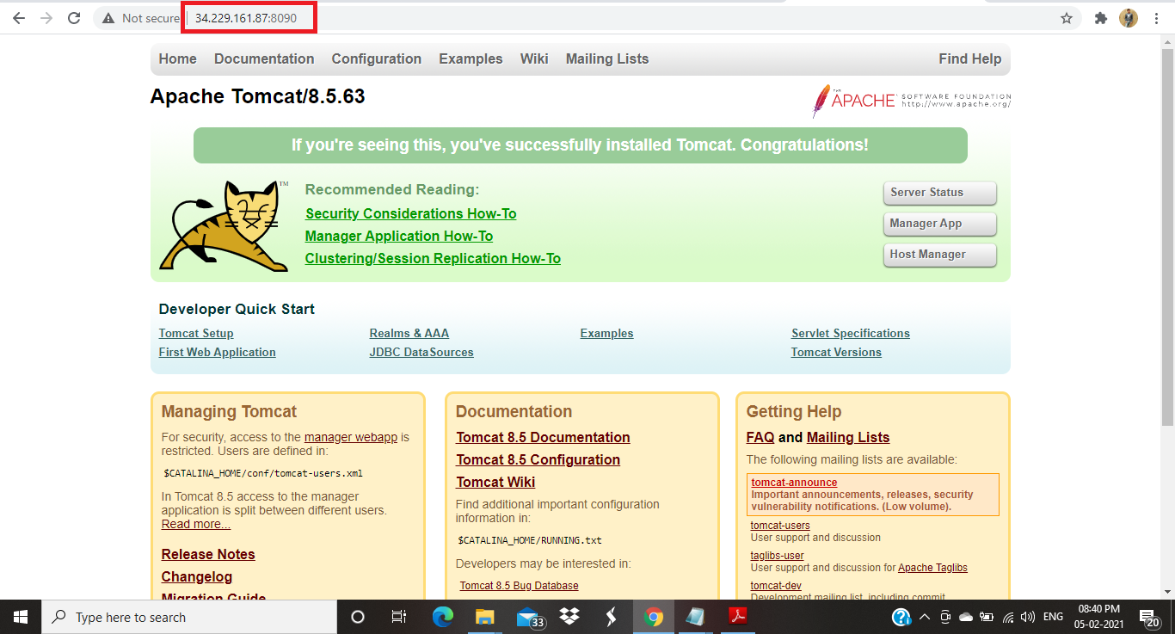

**To allow manager apps access -**

**Edit context.xml to allow manager apps access- vi context.xml**

**To find the patch of context.xml - find / -name context.xml**

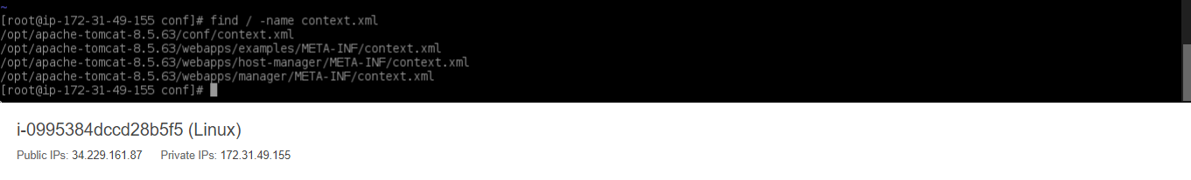

**Comment the value classname tag in context.xml file from hostmanager and manager location-**

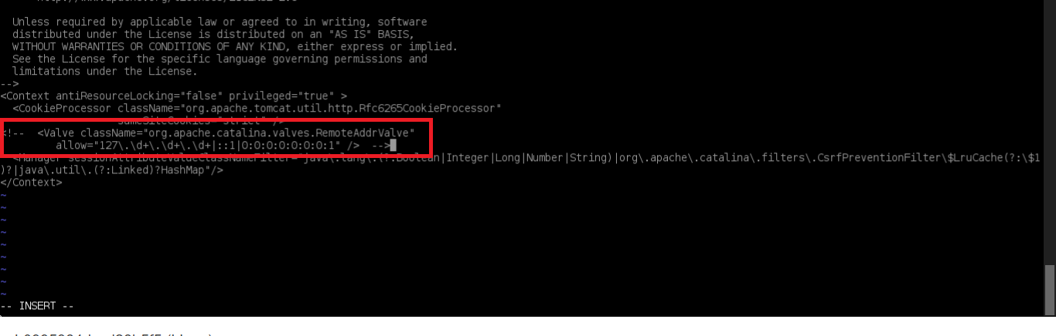

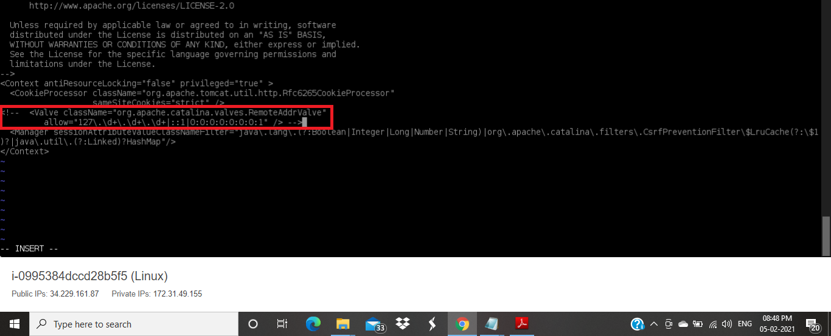

**Add users and roles to tomcat-users.xml – vi tomcat-users.xml**

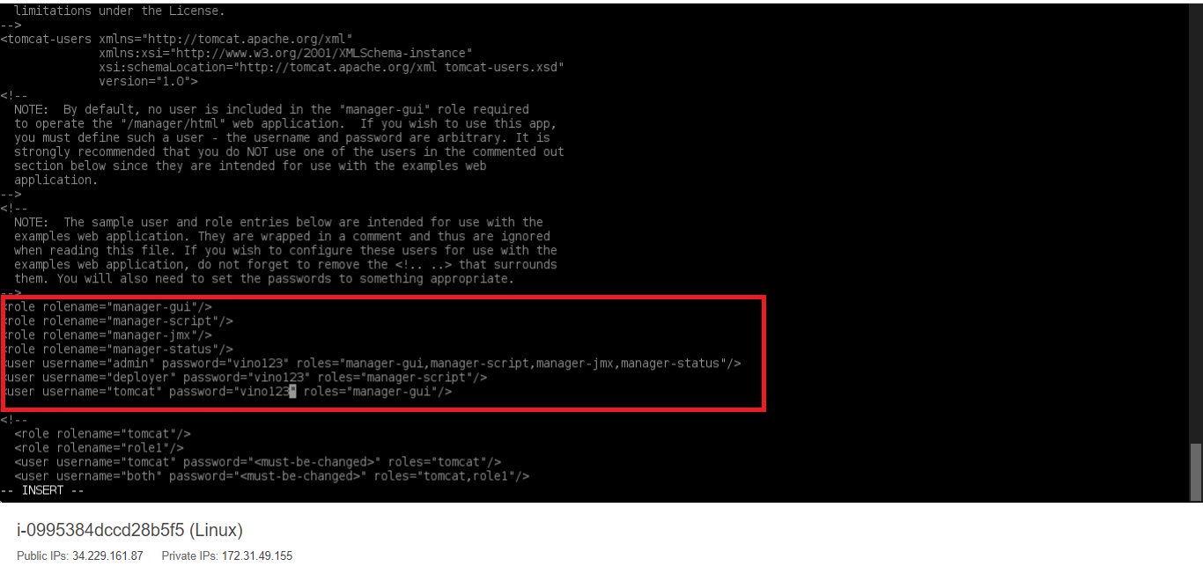

**After using credentials of created users able to access the manager apps-**

